School of Computer Science Engineering & Information Science
A Report on
FEE MANAGEMENT SYSTEM
Course Title: Web Technologies
Course Code: CSE2258

Date of Submission: 21/11/2025

Submitted By:
LABEED - 20241IST0091
ROHAN S - 20241IST0092
TALLAPANENI RAJITHA - 20241IST0093
AMULYA M - 20241IST0094
KAVYA S - 20241IST0095

Index
- Abstract
- Introduction
- Software and Hardware Requirements
- Modules/Functionalities
- Results with Screenshots
- Conclusion

Abstract
The Fee Management System is a web-based application designed to automate and streamline the fee collection process in educational institutions. Traditional manual fee management often leads to delays, errors, and increased administrative workload. This system overcomes these challenges by providing a centralized digital platform where students can securely log in, view fee details, make online payments, and download digital receipts instantly. Administrators can efficiently manage student records, track pending payments, generate reports, and maintain complete transaction histories with improved accuracy and transparency. By integrating essential modules such as login, student dashboard, payment gateway, receipt generation, and admin controls, the system ensures a seamless user experience for both students and staff. Overall, the Fee Management System enhances efficiency, reduces paperwork, minimizes errors, and ensures quick access to fee-related services anytime, making it a reliable and convenient solution for modern educational institutions.

Introduction
The fee collection process is an essential administrative task in every educational institution. However, when handled manually, it often becomes time-consuming, error-prone, and difficult to manage, especially as the number of students increases. To overcome these challenges and improve operational efficiency, digital solutions have become necessary.
The Fee Management System is a simple and user-friendly web-based application designed to automate the entire fee handling process. It allows students to log in securely, check their fee details, make online payments, and instantly receive digital receipts. For administrators, the system provides a centralized platform to manage student accounts, track payments, monitor pending dues, and generate accurate financial reports with ease.
By reducing paperwork, minimizing manual errors, and ensuring transparency in transactions, the Fee Management System significantly improves the overall administrative workflow. It offers 24/7 accessibility, better record keeping, and a smoother experience for both students and staff, making it a modern and efficient alternative to traditional fee collection methods.

Software Requirements
- HTML5 – For structuring web pages
- VS Code / Notepad / Sublime Text – Code editor
- Web browser (chrome, Firefox, Edge) – To run and test the website CSE3 – For styling and layout
Hardware Requirements : Laptop/Desktop
Modules / Functionalities of Fee Management System
1. Login Module.
2. Student Dashboard Module.
3. Payment Module.
4. Receipt Generation Module.
5. Admin Dashboard Module.
6. Report Generation Module.
7. Notification Module (Optional).
8. Home Page Module.

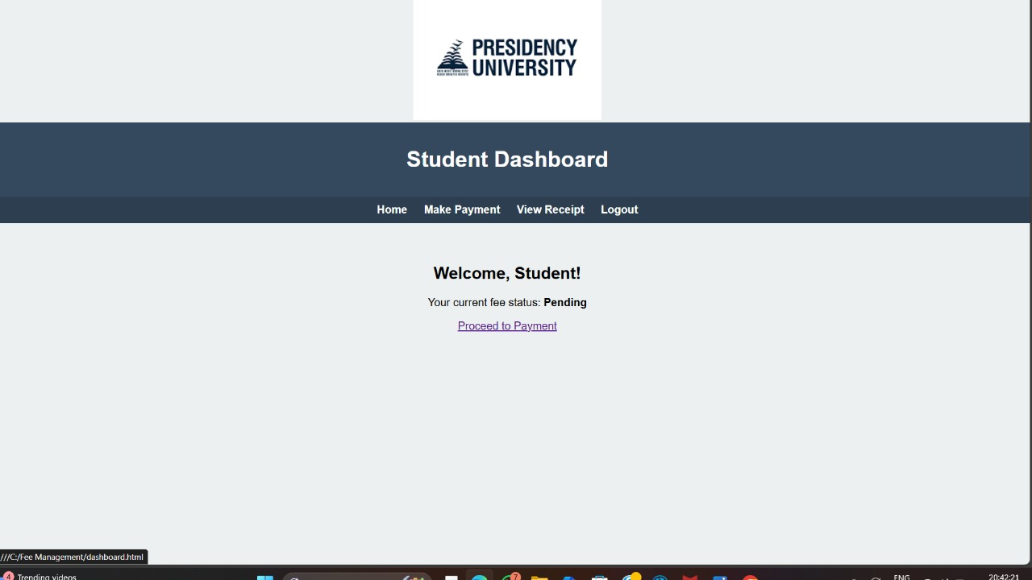
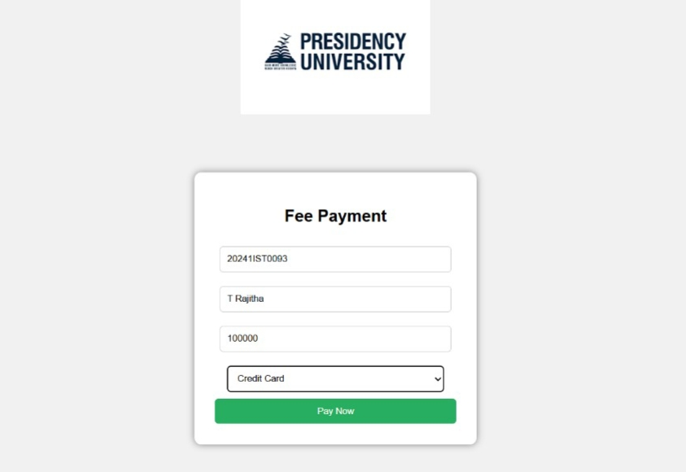
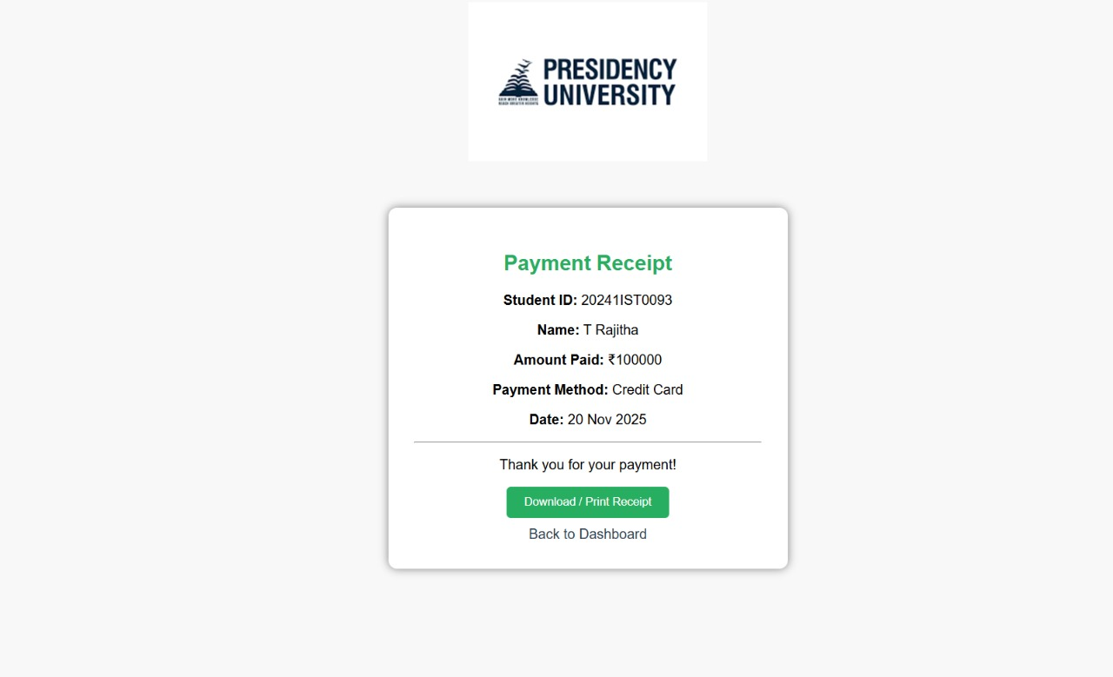

Conclusion
The Fee Management System is an effective web-based solution designed to simplify and automate the fee collection process in educational institutions. By replacing traditional manual methods with a digital platform, the system ensures faster transactions, reduced human errors, and better financial transparency. Students benefit from the convenience of checking fee details, making online payments, and accessing receipts anytime, while administrators can efficiently manage records, track dues, and generate accurate reports.
Overall, the Fee Management System enhances productivity, improves data accuracy, and provides a seamless user experience for both students and staff. This project demonstrates how web technologies can be used to build practical applications that solve real-world administrative challenges and support modern, digital learning environments.

